1. Create new type script program  
   - Open Notepad  
   - Type the following code

function hello()

{

var name = prompt("Enter Name:");

document.write("Hello ! " + name + " Welcome to TypeScript");

}

hello();

* Save in your project folder by name “hello.ts”
* Open your project location in command prompt

> tsc hello.ts [trans compiling into JavaScript]  
 [a new file is generated by name “hello.js”]

- Add a new HTML file “index.html”

<!DOCTYPE html>

<html>

<head> <title> TypeScript </title>

<script type="text/javascript" src="code/hello.js"> </script>

</head>

<body>

</body>

</html>

* Test your application

<http://localhost/tsprograms/index.html>

**Setup Environment for TypeScript with Editor**

**[**Visual Studio Code**]**

1. Download and Install Node JS for Package Manager [NPM]
2. Download and Install TypeScript   
   > npm install -g typescript

> tsc -v [to test the version installed]

3. Download and Install “Visual Studio Code” editor

<https://code.visualstudio.com/>

**Setup Visual Studio Code with Following Plugins**

1. Go to Customize category on home screen and “Install Support for JavaScript”  
   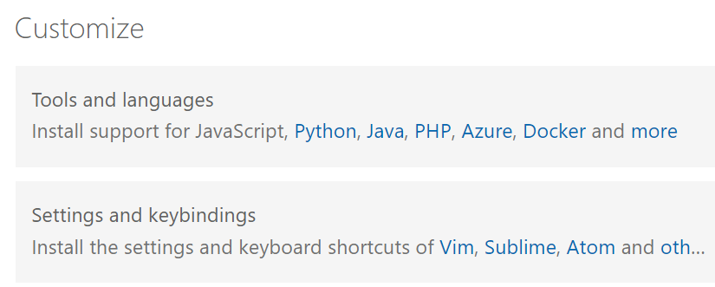
2. Go to Extensions and Install following
   1. Live Server: It configures a local server for you and allows to run your application on

Live local server.  
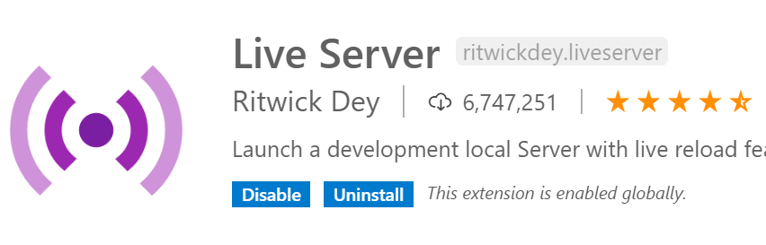

* 1. Vscode-icons: It is to beautify your icons for files. Icon will be more developer

friendly.  
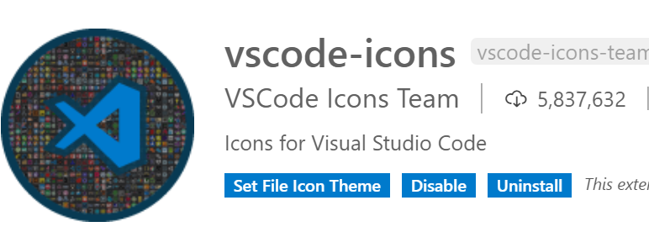

* 1. TsLint: It is code analyser. It allows developers to understand the strict mode of

TypeScript and write code as per standards.  
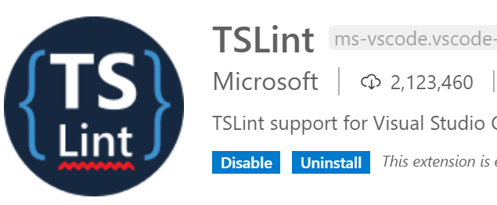

**First TypeScript Project through Visual Studio Code**

1. Create a new folder for your project on your PC (or) You can use the physical folder created for Website.  
   ex: C:\tsprograms
2. Open your folder in Visual Studio Code
3. Add a new file into project  
   **“hello.ts”**

function hello()

{

var uname = prompt("Enter Name");

document.write("Hello ! " + uname);

}

hello();

1. **Trans Compile your TypeScript Program into JavaScript Program.  
   -** Open a command terminal in VS Code “Ctrl + ` “   
    or Terminal Menu -- > New Terminal

**-** Trans compile the program  
 **> tsc hello.ts [**Generates hello.js]

5. Add a new HTML file into your project “Index.html”

<!DOCTYPE html>

<html>

<head>

**<script src="hello.js"></script>**

</head>

</html>

**6.** Run your HTML Page on Live Server

- Right Click in the HTML Page 🡪 Select Open With Live Server

**Compile JavaScript Programs using Node Compiler**

1. Create a new Program

“demo.ts”

var username = "John";

console.log("Hello ! " + username + " How are You?");

1. Trans compile  
   > tsc demo.ts
2. Compile and Run JavaScript Program  
   > node demo.js

**Type Script Language**